**INDEX**

**1. INTRODUCTION**

**1.1 Overview**

**1.2 Purpose**

**2. LITERATURE SURVEY**

**2.1 Existing problem**

**2.2 Proposed solution**

**3. THEORETICAL ANALYSIS**

**3.1 Block diagram**

**3.2 Hardware / Software designing**

**4. EXPERIMENTAL INVESTIGATIONS**

**5. FLOWCHART**

**6. RESULT**

**7. ADVANTAGES & DISADVANTAGES**

**8. APPLICATIONS**

**9. CONCLUSION**

**10. FUTURE SCOPE**

**11. BIBILOGRAPHY**

**1.Introduction**

**1.1. Overview**

Concrete is a material used in construction that has great versatility and which is used across the globe. Concrete has several advantages, including good compressive strength, durability, workability, construction availability, and low cost. Determining accurate concrete strength is a major civil engineering problem. The traditional way to know the strength of concrete will take about 28 days which is very time-consuming. It is important to wait 28 days to ensure the quality control of the process, although it is very time-consuming.

**1.2.Purpose**

To build a Machine Learning model to predict the compressive strength of concrete to greatly speed up prediction with higher accuracy. A web application is built where the user can enter the required parameters and see the predicted results on Web Application.

**2.Literature Survey**

**2.1. Existing Problem**

The Compressive Strength of Concrete determines the quality of Concrete. This is generally determined by a standard crushing test on a concrete cylinder. This requires engineers to build small concrete cylinders with different combinations of raw materials and test these cylinders for strength variations with a change in each raw material. The recommended wait time for testing the cylinder is 28 days to ensure correct results. This consumes a lot of time and requires a lot of labour to prepare different prototypes and test them. Also, this method is prone to human error and one small mistake can cause the wait time to drastically increase.

**2.2. Solution**

To building a Machine Learning model to predict the compressive strength of concrete to greatly speed up prediction with higher accuracy. One way of reducing the wait time and reducing the number of combinations to try is to make use of digital simulations, where we can provide information to the computer about what we know and the computer tries different combinations to predict the compressive strength. This way we can reduce the number of combinations we can try physically and reduce the amount of time for experimentation.

**3. Theoretical Analysis**

**3.1. Block Diagram**

**Machine Learning Model**

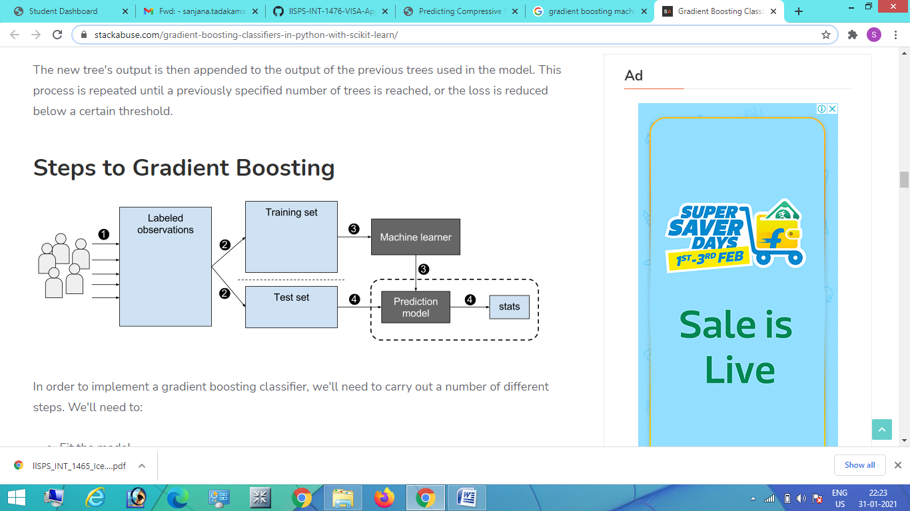

**3.2. Hardware/Software Designing**

The model is designed using Jupyter notebook in Anaconda which is a  open-source distribution of the Python and R programming languages for scientific computing, that aims to simplify package management and deployment.The application building is done using flask which is a web framework that provides tools, libraries and technologies that allow the developer to build a web application. This web application can be some web pages, a blog, a wiki or go as big as a web-based calendar application or a commercial website.

**4.Experimenal Investigations**

Ultra-high performance concrete (UHPC) is a new type of concrete that is characterised by its high compressive strength and excellent durability .It is apparent that the compressive strength of UHPCs decreases with increased FA only. However, in combination with SF, the flexural strength of the UHPC increases. With the increase of SF, the compressive strength of the UHPC increased gradually.

For each mix, sets of three cubes were cast and cured and these were then tested at each of the following test ages: 3 days, 7 days, 14 days and 28 days. A total of 120 cubes were cast and tested.

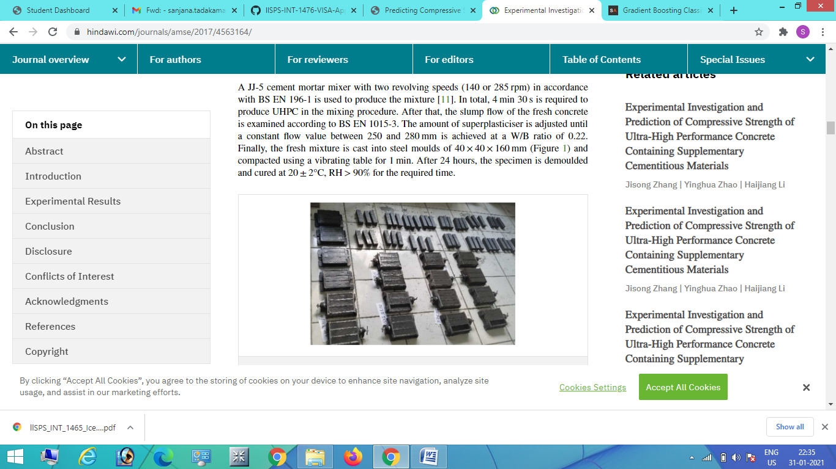

**5.Flowchart**

Data Collection

Data Preprocessing

Model Building

Application Building

**6.Results**

The Machine Learning model was built to predict the compressive strength of concrete to greatly speed up prediction using "Gradient Boosting" algorithm . **Gradient Boosting**trains many models in a gradual, additive and sequential manner. It can be used for both classification and regression problems, which produces a prediction model in the form of an ensemble of weak prediction models, typically decision trees. The model was integrated to a flask web application where it takes inputs and gives the strength of the cement.

**7.Advantages and Disadvantages**

**7.1. Advantages**

* Results have shown Gradient Boosting Trees are better learners than Random Forests.
* GTBs build trees one at a time, where each new tree helps to correct errors made by previously trained tree.
* An efficient algorithm for converting relatively poor hypotheses into very good hypotheses.
* Gradient boosting machines are a family of powerful machine-learning techniques that have shown considerable success in a wide range of practical applications.

**7.2. Disadvantages**

* GBDT training generally takes longer because of the fact that trees are built sequentially.
* Gradient boosting is a greedy algorithm and can over fit a training dataset quickly.

**8. Applications**

* EMG Robotic ARM Controller
* EMG Physical Action Classification
* Text Classification
* Medical Diagnosis

**9. Conclusion**

This model is one of the very interesting examples where machine learning can be used to solve a challenging real-world problem. If we are able to detect the strength of cement by giving inputs of mixtures , then it will help in reducing the number of combinations we can try physically and reduce the amount of time for experimentation.

**10.Future Scope**

Therefore, the future scope of the project will include robust models, which includes the implementation of Artiﬁcial Neural Network Technologies which can predict the results more efficiently (long term prediction) and the processing rate for the dataset in these algorithms is also decreased leading to provide an efﬁcient prediction (in terms of execution time). Also a suggestion of improving the XGBoost for complex datasets which will incorporate the training of real-world datasets where the occurrence of anomalies and noise are inevitable.

**11.Bibilography**

* https://towardsdatascience.com/concrete-compressive-strength-prediction-using-machine-learning-4a531b3c43f3
* https://archive.ics.uci.edu/ml/datasets/Concrete+Compressive+Strength
* https://medium.com/@sattiraju/exploring-the-mutually-inclusive-modern-data-architecture-of-machine-learning-and-serving-1f2a078538c4
* https://stackabuse.com/gradient-boosting-classifiers-in-python-with-scikit-learn/
* https://core.ac.uk/download/pdf/55305138.pdf